<https://playground.tensorflow.org/#activation=relu&batchSize=10&dataset=spiral&regDataset=reg-plane&learningRate=0.01&regularizationRate=0&noise=5&networkShape=7,7&seed=0.73823&showTestData=false&discretize=false&percTrainData=50&x=true&y=true&xTimesY=false&xSquared=false&ySquared=false&cosX=false&sinX=false&cosY=false&sinY=false&collectStats=false&problem=classification&initZero=false&hideText=false>

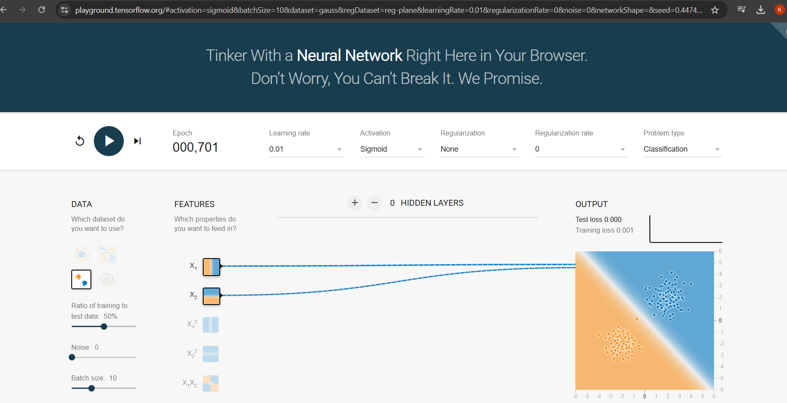

If we want to see the example of perceptron is not working in the non linear data go to this link and see with examples try with different different data.

In this there is 0 Hidden layers

If we select multiclass classification data then use multiple perceptrons use multiple hidden layers use multiple neurons we can also change the learning rate also.

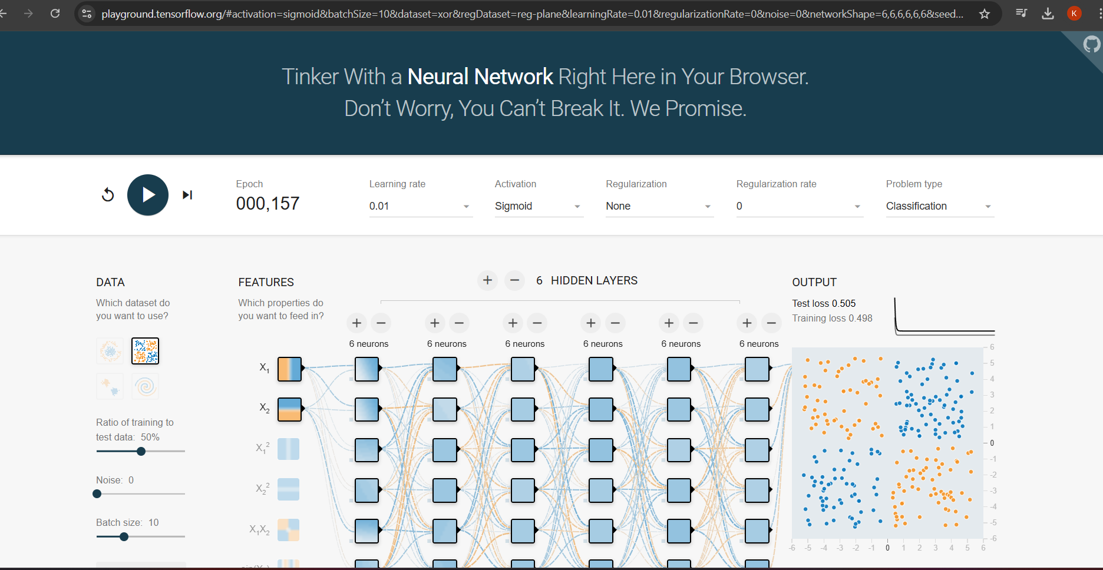

<https://www.tinkershop.net/ml/sigmoid_calculator.html>

<https://adamharley.com/nn_vis/mlp/3d.html>

<https://adamharley.com/nn_vis/mlp/2d.html>